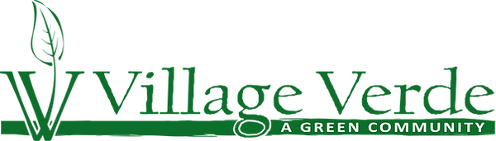

NOTICE AND AGENDA
ANNUAL MEMBERSHIP MEETING
Village Verde Owners Association (“Association”)
(www.villageverdeok.com/home-owners-association)
Monday, March 9, 2026, 6:00 P.M.
Surrey Hills Baptist Church, 12421 North Mustang Road, Yukon, Oklahoma

- Preliminary Matters:
  - Association Annual Membership Meeting called to order by Association President, Chair of Annual Membership Meeting, and Manager, Village Verde Developers, LLC, (“Declarant”), Kelly Parker. P.E. (3 Minutes)
  - Introduction of Visitors by Chair (2 Minutes)
    - Note all Members and Visitors must sign in at door.
  - Quorum: Declarant Present. Declarant retains all voting authority for all Lots for all purposes, including appointing all Board Members and Officers under CCR Section 14; Bylaws, Article III, Section 8; Article V, Section 2 by Association Counsel.
  - Call for approval of all past Association Annual Meeting Minutes by Association Treasurer posted at https://www.villageverdeok.com/hoaminutes and incorporated by reference, Association Treasurer, Dana Parker (2 Minutes)
- Old/Unfinished Business:
  - General discussion
    - Declarant retains all voting authority for all Lots for all purposes, including appointing all Board Members and Officers under CCR Section 14; Bylaws, Article III, Section 8, and Article V, Section 2
    - All Member disputes must comply with Dispute Resolution Procedures under CCR, Article 4, Section 4.12
      - Discussion/Questions
2.2.3 Dale Sanders producing Newsletter – Thank you
2.2.4 Village Verde maintains only 1 Facebook page (Village Verde OKC) and 1 website (www.villageverdeok.com). No others are monitored or responded to.
  - Officer Reports:
    - Association President and Architectural Committee Report, Kelly Parker (10 minutes)
      - Attachment 1 2025 Association President and Architectural Committee Report
        - Discussion/Questions

    - Treasurer’s Report, Dana Parker, Treasurer, (10 Minutes) (CCR Article 4, Section 4.8, Article 7)
      - Attachment 2 Association 2025 Statement of Unpaid Assessments for each Lot (CCR, Article 7.2)
      - Attachment 3 Association 2025 Financial Statements (Bylaws, Articles IX, Section 4.8)
      - Attachment 4 Association 2025 Statement of Income and Expenditures (Bylaws, Articles X, Section 9 (d))
      - Attachment 5 Association 2026-2029 Three Year Annual Budget (Bylaws, Articles X, Section 9 (d))
        - Chair called for Motion to Approve Association Attachment 5 Association 2026-2029 Annual Budget
          - Chair and Treasurer lead Discussion/Questions
            - Declarant to Vote
  - Committee Reports:
    - Nominating Committee for Association Board/Officers (Kelly Parker, Chair) (3 Minutes)
      - Declarant retains all voting authority for all Lots for all purposes, including appointing all Board Members and Officers under CCR Section 14; Bylaws, Article III, Section 8; Article V, Section 2Declarant appoints the following Officers and Directors for the Association for 2026:
          - President – Kelly Parker, P.E.
          - Vice President – Scottie Bryan
          - Secretary – Matt McGuire
          - Treasurer – Dana Parker, CPA
- New Business:
  - Notice and Agenda timely distributed to Association Members
  - Dirt moving occurring on NW Expressway & Mustang in preparation of potential commercial lot sales (Domino’s Pizza, Dental Depot)
- Adjournment and Announcement of Next Annual Meeting by Chair (2 minutes)
  - 2027 Association Annual Meeting, will be first part of March 2027 at:
    - 6:00 p.m. at Surrey Hills Baptist Church, 12421 North Mustang Road, Yukon, Oklahoma
  - Call by Chair Motion for Adjournment
Attachments:
- Attachment 1 2025 Association President and Architectural Committee Report
- Attachment 2 2025 Association Statement of Unpaid Assessments for each Lot
- Attachment 3 2025 Association Financial Statements
- Attachment 4 2025 Association Statement of Income and Expenditures
- Attachment 5 2026-2029 Association Three Year Annual Budget
Attachment 1 2025 Association President and Architectural Committee Report

- Purpose of Village Verde Owners Association
- The Association must maintain our community resources to uphold the individual home and Unit values and enhance the long-term commitments as more fully described in the CCR’s. The CCR’s can be found at www.villageverdeok.com.
- Covenants, Conditions and Restrictions (All Members agreed to the CCR’s when they purchased their property). “Section 4.2 . . . . Each person taking title to a Unit within Village Verde takes expressly subject to the Governing Documents.”
- Tree requirements – 2 – 2” diameter or caliper trees unless on corner lot then an additional 3rd tree (1.5” diameter) is required. The 2025 HOA fine for not meeting the requirements is $100/monthly. Enforcement began on January 1, 2025.
- Village Verde is a rent restricted community – Leased/Rented homes are limited amount to 10% UNLESS ZONED FOR MULTIFAMILY (SOUTH LOTS AND NEXT SECTIONS) and are required to pay $50/year for registration. The list is maintained at VVD office.
- Village Verde Association Owner dues are $450/annually for all sections. Fees late by January 15th. If you pay online there is an additional fee. As of June 2024, it is legal to charge a surcharge for using a credit card in Oklahoma, even though the state’s law prohibits it. This is because federal courts have ruled that the state’s law is unconstitutional. Eliminate the fee and mail a check or money order. Liens will be filed by April 1, 2026.
- In 2025, Architectural Committee responded to: 1 backyard patio application; 1 shed application; 1 astroturf application; 1 little library application and 1 upgraded landscape/fence application.
- These addresses have liens filed for earlier years (non-payment of dues): 11400 NW 134th St.; 11408 NW 134th St.; 11425 NW 130th St.; 11433 NW 129th St.; 11441 NW 132nd Terr.; 11444 NW 129th St.; 11448 NW 130th St.; 11512 NW 132nd Terr.; 12817 Running Pebble Rd.; 13104 Native Plant Rd.; 13300 Greenscape; 13304 Greenscape; 13308 Outdoor Living Dr.; 13309 Outdoor Living Dr.; 13328 Outdoor Living Dr. and 13608 Front Porch Dr. These addresses have liens filed for the first time last year (2025): 13112 Running Pebble Rd.; 13308 Greenscape; 13320 Outdoor Living Dr. and 13340 Outdoor Living Dr. The liens represent in excess of $21,350.00 of uncollected HOA dues (this total does not include filing fees, interest, and any attorney fees and costs to date).
- As of February 6, 2026, these addresses are in non-compliance of tree ordinance and are accruing $100 monthly fees: 11441 NW 132nd, 11505 NW 129th St and 13300 Greenscape.
- If your house backs up to a common area, that fence must be a metal fence as detailed in CCR. Enforcement of $100/month went into effect March 1, 2024.
- New changes to CCR 3 years ago, gives the Association right to assess monthly fees for noncompliance and other essential Association administrative duties and fees.
- New Construction Update (Feb. 2024, Section 4A/4B – 62 lots).
- No new updates on construction activities for next section 4C.
- Have issues with construction traffic or debris – take pictures and send to Association at info@villageverdeokc.com.
- Taber Homes has purchased all lots in 4A/4B. Taber Homes has also committed to drill a well to maintain the pond level on Section 4A. They did the well and now dry redrilling.
- Community Engagement
- The Association encourages applications from any Member in good standing to serve or chair any of the Association Advisory Board, Finance, Landscape, or Operations Committees.
- Annual Garage Sale - possibly in the Fall, only with enough interest. Please email us if you want to sign up. We will also need to have your email address on file for notification as required by the CCR’s.
- July 4th Celebration Parade: HOA Meetings: Summer Splash Pad Party.
- More could be scheduled if a community member wants to take the lead to organize. Email: info@villageverdeokc.com
- A number of Association Members hired an Attorney in 2023 to contest increase in fees and review books/authorities. The cost for Association defense attorney is an Association expense (2024 expenses over $50,000) under the CCR Article IV, Section 4.12. Financial Overview of 2023 HOA Distributions
- Under reasonable notice, and by prior appointment, on weekdays and during normal business hours, any Association Member can inspect the names and addresses of the Association Members. If more information is requested, the specific information sought must be requested by the Member in a signed writing, outlining a proper purpose and a credible basis before the Association's will produce responsive confidential information and documents which may be inspected.
- Attorney has not continued correspondence with association attorney after April of 2024.

NEWS FROM 2025:
- Rental restrictions (10%) enforced
- Several cars/boats parking on street – Enforced – First contact owner if it’s an issue.
- Deficit funding – (Please pay your dues- over $21,350.00 currently with liens)
- An extension of the loop of sidewalks was completed in 2025 on Section 4A – 4B. Sidewalks are not for motorized vehicles. Please comply for everyone’s safety. Police will be called.

Oklahoma City Motorized Vehicle Ordinances:
§ 32-582. - Limitation on use of motorcycles and motor scooters.
(a) No driver of a two- or three-wheel motor vehicle shall carry any other person upon or within such vehicle on any street or highway, except as provided below:
(1) if any two- or three-wheel motor vehicle with a wheel diameter of 12 inches or greater shall have either a double seating device with double foot rests or a side car attachment providing a separate seat space within such side car attachment for each person riding therein so that such person shall be seated entirely within the body of said side car, then it shall be permissible for an operator who has attained the age of 16 or older to carry a passenger;
(2) a demonstration ride by a licensed dealer or his employee is permissible.
(b) No motorcycle or motor scooter shall be ridden upon any sidewalk.
(c) Handlebars on motorcycles and motor scooters shall not exceed 12 inches in height, measured from the crown or point of attachment.
(d) No rider of a motorcycle or motor scooter shall hold to any moving vehicle for the purpose of being propelled. (Code 1970, § 34-69; Code 1980, § 32-581; Ord. No. 24273, § 3, 5-24-11)

State Law reference - Limitations on use of motorcycles and motor scooters, 47 O.S. §§ 11-1103, 12-609.
§ 32-583. - Special speed limitation on motorcycles and motor scooters.
No person shall operate any motorcycle or any motor scooter at a speed greater than the speed limit legally posted. In no event nor at any time may an operator under the age of 16 years operate a motorcycle or motor scooter at a speed greater than 35 miles per hour. (Code 1970, § 34-70; Code 1980, § 32-582)

UPDATES FOR DEVELOPMENT

- Next Sections: Section 4C – 62 lots

- Please email info@villageverdeokc.com with current contact information and/or any changes in contact information. Please keep your contact information current as required under the Association CCR and Bylaws.

Name | Street | City | State | ZIP
Tyler Stitt & Kassidi Ashley | 11400 NW 134th | Piedmont | OK | 73078
Tracey and Kari Gatewood | 11409 NW 136th Terrace | Piedmont | OK | 73078
David Reaves | 11417 NW 132nd Terr | Piedmont | OK | 73078
Tony Dowling & Ginger Dowling | 11425 NW 130th | Piedmont | OK | 73078
Jennifer Struss | 11433 NW 132nd Terr | Piedmont | OK | 73078
Angela Matthews | 11437 NW 130th | Piedmont | OK | 73078
Jeffrey Taylor | 11440 NW 129th Street | Piedmont | OK | 73078
Sean Puckett | 11441 NW 132nd Terr | Piedmont | OK | 73078
Joshua Rivera | 11444 NW 129th Street | Piedmont | OK | 73078
Merry Weatherby | 11444 NW 131st | Piedmont | OK | 73078
Cao and Den Do Nguyet | 11449 NW 130th Street | Piedmont | OK | 73078
Jose Lopez | 11452 NW 131st Street | Piedmont | Ok | 73078
Jaritza Escobar & Alexis Ramirez | 11501 NW 130th | Piedmont | OK | 73078
Marcus Ary | 11505 NW 129th Street | Piedmont | OK | 73078
Charlotte Phillips | 11512 NW 129th Street | Piedmont | OK | 73078
Mayka Stell | 11512 NW 132nd Terrace | Piedmont | OK | 73078
Dylan Kai Nguyen | 11512 NW 134th Terrace | Piedmont | OK | 73078
Dina Spain | 11513 NW 131st | Piedmont | OK | 73078
Colton Demuth & Katie Lippoldt | 11516 NW 132nd Terr | Piedmont | OK | 73078
Ondrea Wade | 11517 NW 131st | Piedmont | OK | 73078
Tara Harris | 11524 NW 132nd Terr | Piedmont | OK | 73078
Brody & Brittany Follis | 12808 Double V Dr | Piedmont | OK | 73078
John and Sissi Pike | 12817 Running Pebble Rd | Piedmont | OK | 73078
Daniel Garcia | 12905 Double V Dr | Piedmont | OK | 73078
Brandon Meadows | 12925 Running Pebble Rd | Piedmont | OK | 73078
Wendi Piatt | 12940 Running Pebble Rd | Piedmont | OK | 73078
Matthew and Miranda Clark | 13020 Running Pebble Rd | Piedmont | OK | 73078
Stacey and Brian Chandler | 13104 Native Plant Rd | Piedmont | OK | 73078
Hugo & Manuel Cuellar | 13300 Greenscape | Piedmont | OK | 73078
Elena Kirpicheva | 13301 Greenscape | Piedmont | OK | 73078
Terry Shepherd | 13304 Greenscape | Piedmont | OK | 73078
Jason Hatfield | 13308 Greenscape | Piedmont | OK | 73078
David Patman | 13308 Outdoor Living Dr | Piedmont | OK | 73078
Robert G II & Krista Starr | 13309 Outdoor Living Dr | Piedmont | OK | 73078
Jonathan and Alicia Henderson | 13313 Tree Gazing Way | Piedmont | OK | 73078
Ellen Helen Thomas | 13316 Outdoor Living Dr | Piedmont | OK | 73078
Patrick Wright & Nicole Clay | 13320 Outdoor Living Dr | Piedmont | OK | 73078
Lane and Amanda Bennett | 13324 Outdoor Living Dr | Piedmont | OK | 73078
Zachary Stone | 13328 Outdoor Living Drive | Piedmont | OK | 73078
Hieu Tang | 13340 Outdoor Living Dr | Piedmont | OK | 73078
Tanner & Amanda Upchurch | 13409 Outdoor Living Dr | Piedmont | OK | 73078
Nina DeSalle | 13417 Open Air Lane | Piedmont | OK | 73078
Brandon and Jacqueline Sharp | 13504 Firethorn Drive | Piedmont | OK | 73078
Johnathan & Delanie O'Toole | 13504 Front Porch Dr | Piedmont | OK | 73078
Marquis Dickson | 13509 Firethorn Dr | Piedmont | OK | 73078
Jeff Cook | 13609 Firethorn Dr | Piedmont | OK | 73078
Stephen & Teresa Prentice | 13120 Running Pebble Rd | Piedmont | OK | 73078
Dia R Hadley | 11444 NW 130th St | Piedmont | OK | 73078
Attachment 2 2025 Association Statement of Unpaid Assessments for each Lot

Attachment 3 2025 Association Financial Statements

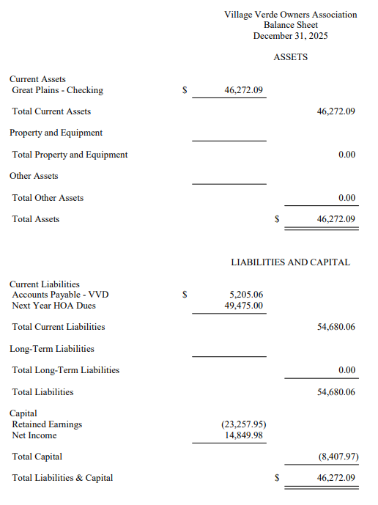

Attachment 4 2025 Association Statement of Income and Expenditures

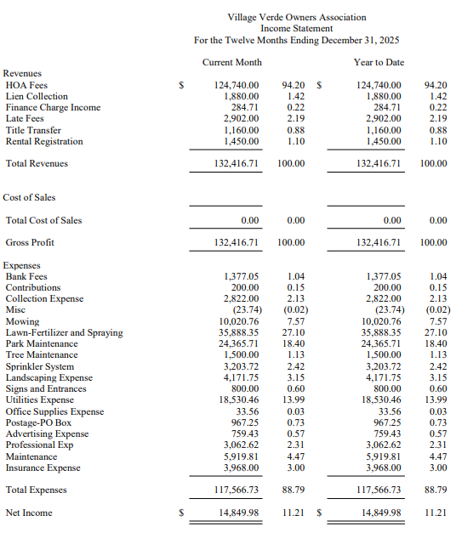

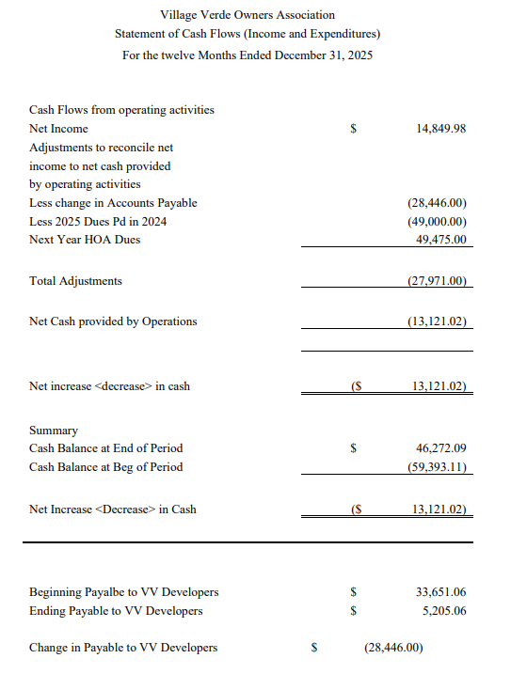

Attachment 5 2026-2029 Association Annual Budget
